d

TOne WholeSale System Technical Design

Contents

Document Purpose 3

System Modules 4

Business Entities Module 6

Entities Definition 6

Suppliers 6

Sale Zones 7

Customers 7

Routing Product 8

Selling Product 9

Management Screens 10

Business API 10

Code Preparation Module 12

Supplier PriceList Module 13

Routing Module 14

Routing Process Inputs 14

Routing Process Output 14

RoutingProductOptions 14

SellingProductRoute 14

CustomerRoute 15

Routing Full Process 15

Build Routes Sub Process 16

Execute Routing Rule 18

Retrieve Most Restricted Rule 18

Sales Module 20

Selling Product 20

Selling Product Definition 20

Rate Planning 20

Selling Rules 21

Assigning Customers to Product 21

Customer Pricing 22

CDR Processing 23

# Document Purpose

The purpose of this document is to discuss the technical design of the new TOne WholeSale system. This new system is a replacement of the existing TOne system. The design of the new system shall consider the followings:

* It shall include all functionalities available in the current system and shall provide additional functionalities
* It shall solve all performance issues in the current system
* It shall give a new and impressive user experience
* It shall be designed in way that allows adding more features and even more types of business (e.g. National Traffic Management) in the future.

The new TOne WholeSale system will be known hereafter as “the system”

# System Modules

The architecture of the system would be modular-based where multiple technical modules connected together form the whole system. The technical modules that makes the core functionality of the system are:

|  |  |  |  |
| --- | --- | --- | --- |
| Module Name | Technical Name | Description | Dependent On |
| Business Entities Module | WhS.BusinessEntity | This module consists of the definitions of the business entities of the system (e.g. Customers, Suppliers, Sale Zones...). In addition, it includes management API and screens of the entities that are straight forward to manage (e.g. Carrier Accounts, Rules…) |  |
| Code Preparation Module | WhS.CodePreparation | This module consists of the Code Preparation process and its related parts. The job of this process is to define and update the Sale Zones and Codes | Business Entities Module |
| Supplier PriceList Module | WhS.SupplierPriceList | This module consists of the Import Supplier Price List process and its related parts. The job of this process is to define and update the Supplier Zones, Codes, and Rates | Business Entities Module |
| Routing Module | WhS.Routing | This module consists of the Build Routes process and its related parts. The job of this process is to generate routes that would be synchronized with the switch(es). And to generate route options based on destinations that would be used by the sales team while pricing | Business Entities Module |
| Sales Module | WhS.Sales | This module consists of the sales processes and their related parts. The main part of this module is the rate planning. It is used by the sales team and its main job is to define and update the sale rates | Business Entities Module, Routing Module |
| CDR Processing Module | WhS.CDRProcessing | This module consists of the processes that import CDRs from the switch(es) and do needed manipulation and transformation on them. This includes pricing and summary calculation | Business Entities Module |

The following diagram shows the structure and dependencies of the system modules:

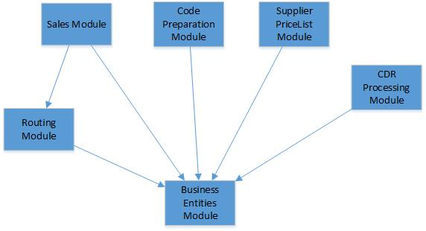

The below sections discuss these modules in further details

# Business Entities Module

The Business Entities module consists of the definitions of core entities of the system. In addition, it includes management API and screens of the entities that are straight forward to manage (e.g. Carrier Accounts, Rules…).

The main entities in the system are:

* Suppliers
* Sale Zones
* Customers
* Routing Products
* Selling Products

## Entities Definition

### Suppliers

A Supplier is a Carrier Account that acts as a supplier. Each supplier has its own Zones definition and its own rates

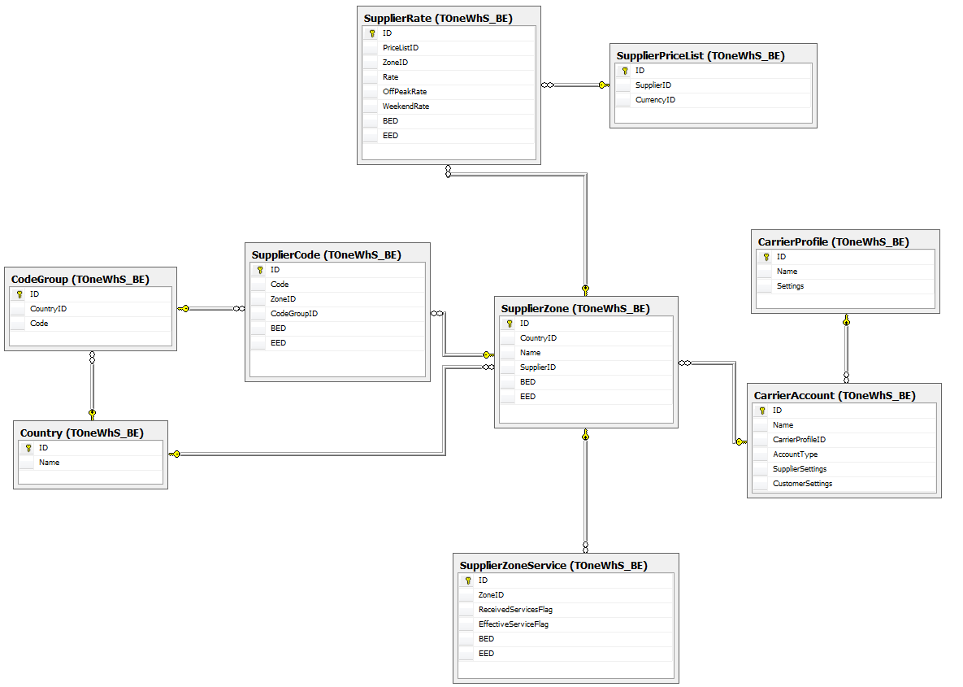

### Sale Zones

A client would be able to define one or multiple Selling Number Plans used to design its sales strategy. A Sale Zone Numbering Plan consists of a set of Sale Zones each of which consists of a set of Sale Codes

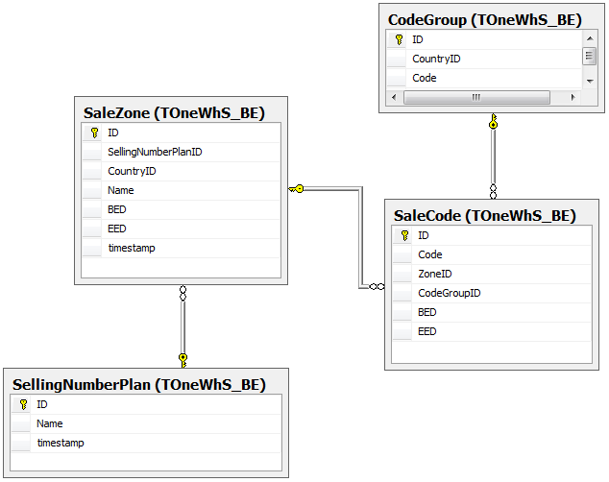

### Customers

A Customer is a Carrier Account that acts as a customer. A Customer should be assigned a single Selling Number Plan. The Selling Number Plan is assigned one time and cannot be changed in the future

The main attributes of the Customer are:

|  |  |
| --- | --- |
| Attribute | Notes |
| Name | String value |
| Selling Number Plan | This value is assigned at creation time and cannot be changed |

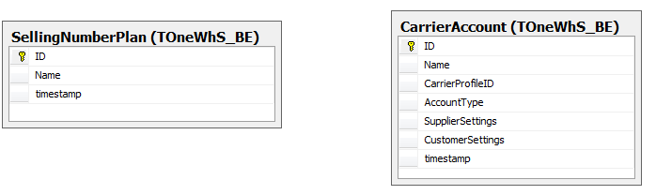

### Routing Product

The purpose of a Routing product is to provide the customer with voice service at a specific cost and quality. A Routing Product consists of a group of zones and it is configured with a routing strategy

The main attributes of the Routing product are:

|  |  |
| --- | --- |
| Attribute | Notes |
| Name | String value |
| Selling Number Plan | This value is assigned at creation time and cannot be changed |
| Sale Zones | * All * Specific Zones   Each Zone would have a specific Service Flag |
| Suppliers | * All * Specific Suppliers |
| Routing Rules | Each routing rule would consist of the followings:   * Criteria:   + Zones * Action:   + Route Type     - Fixed Route     - Automatic Route   + Percentage Settings   + Filter Options   + Order Options |

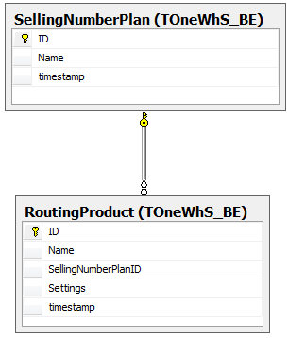

### Selling Product

The purpose of the Selling product is to define a selling strategy and assign it to a group of customers.

The main attributes of the Selling product are:

|  |  |
| --- | --- |
| Attribute | Notes |
| Name | String value |
| Selling Number Plan | This value is assigned at creation time and cannot be changed |
| Routing Product | The default Routing Product used for Cost analysis in order to decide selling rates |
| Rates | The rates decided on the product |
| Selling Rules | Rules defined on the product that restrict the prices defined by the account managers on the related customers. Each rule would consists of:   * Criteria:   + Zones   + Customers * Action:   + Locked Rate   + Open Rate with Margin Settings |

Each customer should be assigned to a single Selling product at a specific point of time

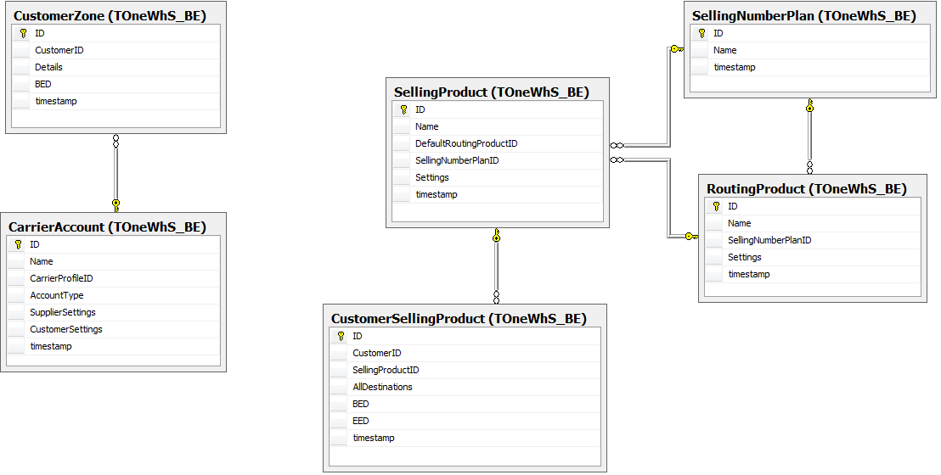

## Management Screens

The main management screens that shall be included in the Business Entities module are:

|  |  |  |
| --- | --- | --- |
| Screen Name | Description | Affected Tables |
| Carrier Profile Management | Carrier Profile management | CarrierProfile |
| Carrier Account Management | Management of Suppliers and Customers accounts | CarrierAccount |
| Code Group Management | Code Groups (Countries) | CodeGroup |
| Currency Management | Currency | Currency, CurrencyExchangeRate |
| Zone Service Management | List of Possible Zone Service | ZoneServiceConfig |
| Selling Number Plan Management | Selling Number Plan | SellingNumberPlan |
| Routing Product Management | Routing Products | RoutingProduct |
| Route Rule Management | Route Rules (Product-related rules and exception rules) | RouteRule |
| Route Option Rule Management | Route Option Rules | RouteOptionRule |
| Selling Product Management | Selling Products | SellingProduct |
| Customer to Product Relation | Relation between Customers and Selling products | CustomerSellingProduct |
| Selling Rule Management | Selling Rules | SellingRule |
| Pricing Rule Management | Pricing Rules | PricingRule |

## Business API

The following table shows the main business managers that are included in the Business Entities module with the types of operations that they provide:

|  |  |  |  |  |
| --- | --- | --- | --- | --- |
| Business Manager | Get | Add | Update | Delete |
| CarrierProfileManager | X | X | X | X |
| CarrierAccountManager | X | X | X | X |
| CodeGroupManager | X | X | X | X |
| CurrencyManager | X | X | X | X |
| ZoneServiceManager | X | X | X | X |
| SellingNumberPlanManager | X | X | X | X |
| SaleZoneManager | X |  |  |  |
| SaleCodeManager | X |  |  |  |
| SaleRateManager | X |  |  |  |
| SaleZoneServiceManager | X |  |  |  |
| SalePriceListManager | X |  |  |  |
| SupplierZoneManager | X |  |  |  |
| SupplierCodeManager | X |  |  |  |
| SupplierRateManager | X |  |  |  |
| SupplierZoneServiceManager | X |  |  |  |
| SupplierPriceListManager | X |  |  |  |
| RoutingProductManager | X | X | X | X |
| RouteRuleManager | X | X | X | X |
| RouteOptionRuleManager | X | X | X | X |
| SellingProductManager | X | X | X | X |
| SellingRuleManager | X | X | X | X |
| PricingRuleManager | X | X | X | X |

# Code Preparation Module

This module consists of the Code Preparation process and its related parts. The job of this process is to define and update the Sale Zones and Codes.

A new screen shall be available to submit sale zones and codes for a specific Selling Number Plan. And new workflow shall be created

This module is still under investigation

# Supplier PriceList Module

This module consists of the Import Supplier Price List process and its related parts. The job of this process is to define and update the Supplier Zones, Codes, and Rates

A new screen shall be available to submit Supplier Zones, Codes, and Rates for a specific Supplier. And new workflow shall be created

This module is still under investigation

# Routing Module

This module consists of the Build Routes process and its related parts. The job of this process is to:

* Generate routes that would be synchronized with the switch(es)
* Generate route options based on destinations that would be used by the sales team while pricing (i.e. Cost Analysis)

## Routing Process Inputs

The routing process basically relies on the following inputs:

* Customer
* Sale Zones
* Sale Rates
* Supplier
* Supplier Zones
* Supplier Rates
* Routing Products
* Routing Rules

## Routing Process Output

The output of the Routing Process is a new routing database consisting of the following tables:

### RoutingProductOptions

This table stores the route options by Sale Zone for each Routing product:

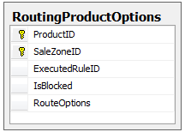

### SellingProductRoute

This table stores the route options by Code for each Selling product. This table acts as shared routing for multiple customers:

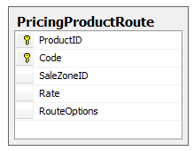

### CustomerRoute

This table stores the route options by Code for each customers:

* In case the customer has a specific route options, the Route shall be stored in this table
* In case the customer is sharing the route options with other customers, the Route shall be stored in and retrieved from the SellingProductRoute table

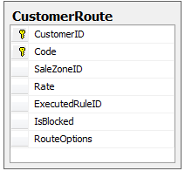

## Routing Full Process

The main Routing process relies on the concept of dividing distinct codes into a set of code prefixes where each prefix could be processed independently. And then for each code prefix, a separate sub process would be initialized. The full process is depicted in the following diagram:

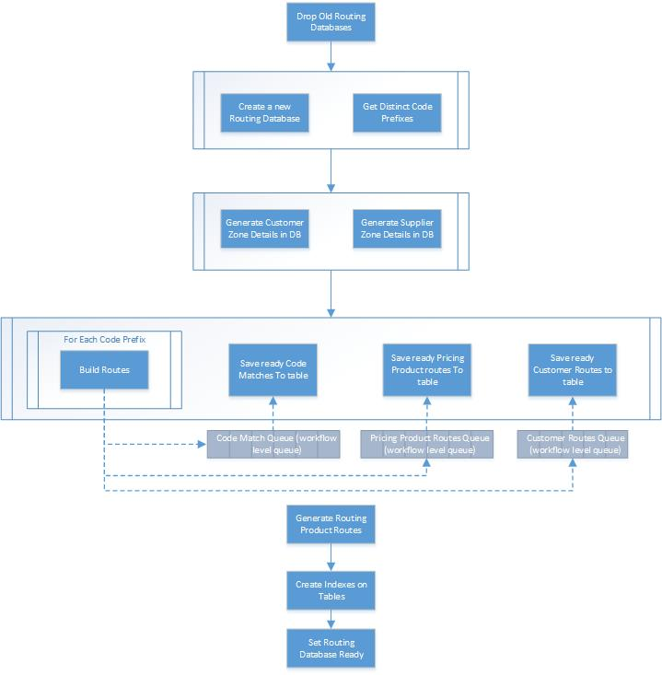

### Build Routes Sub Process

The Build Routes sub process takes a code prefix as input, and it builds routes on two levels:

* Selling Product routes by Code
* Customer routes by Code

It is depicted in the following diagram:

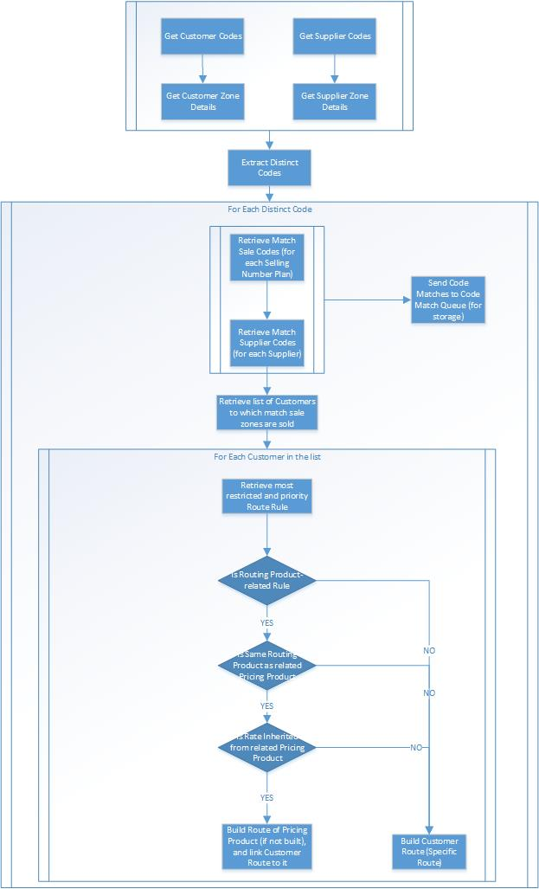

### Execute Routing Rule

The main logic of building the Route Options is executed by the applicable Routing Rule. The Routing rules to execute are retrieved in the Build Routes sub process on two levels:

1. By Routing Product
2. By Customer

The main execution flow of the Routing rules is depicted in the following diagram:

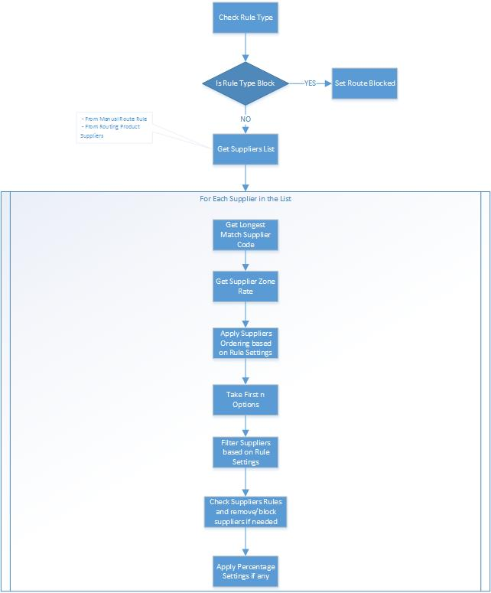

### Retrieve Most Restricted Rule

The following diagram shows the sequence of checks to retrieve the most restrictive and priority rule to execute on a Customer level in order to build the Route Options:

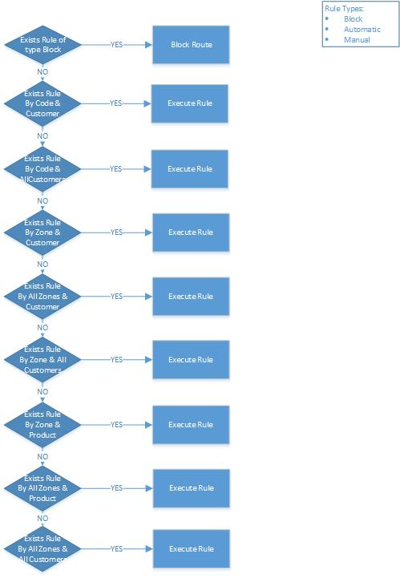

# Sales Module

This module consists of the sales processes and their related parts. The main part of this module is the rate planning. It is used by the sales team and its main job is to define and update the sale rates.

This module also includes a Cost Analysis part used to enable the account managers to give more appropriate prices to their customers.

Cost Analysis and Pricing is performed on two levels:

* Selling Product
* Customer

## Selling Product

The purpose of the Selling product is to define a selling strategy and assign it to a group of customers. The management screen of the selling product shall consist of the following sections:

### Selling Product Definition

In this section, the user:

* Sets the name and the description of the Selling Product

### Rate Planning

In this section, the user sets a rate on each sale zone after doing Cost Analysis. To do Cost Analysis, the system relies on the Routes produced by the Routing process on the Routing product level. The Routing product is set on the Selling product level and can be also overridden on the Zone level.

After doing rate planning, the rates are stored in the database for the Selling product. Those rates are used as initial values on the Customers assigned to the selling product.

Whenever the user does rate planning and clicks Apply, a new record in the SalePriceList table having OwnerType equals to Selling Product type. And each rate record is stored in the SaleRate table:

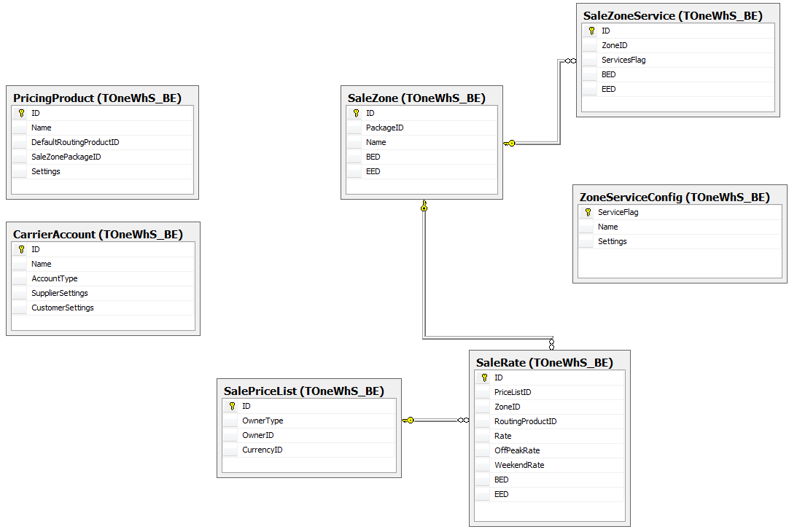

### Selling Rules

In this section, the user defines the selling rules that control and restrict the rates defined by the account managers on the customer level. A selling rule consists of:

* Criteria:
  + All Zones or specific Zones
  + All Customers or specific Customers (from the list assigned to the product)
* Action:
  + Locked Price
  + Open Price with Margin settings. The margin settings can be defined based on the User Level

### Assigning Customers to Product

In this section, the user assigns customers to the selling product. The following rules shall apply:

* Each customer should be assigned to a single selling product at a specific point of time
* In this section, the user can select the Effective time of the assignment

This relation is stored in the CustomerSellingProduct table

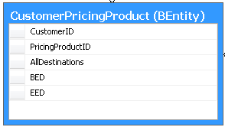

## Customer Pricing

The pricing on the customer level shall be in the rate planning screen (same one of the Selling product).

In order to do pricing, the customer should be first assigned to a Selling product as discussed previously. This task shall be done by a senior manager (a User who has permission to assign customers to products).

In this screen, the Account Manager shall initially see the rates based on the Selling product rates. He can do cost analysis based on the selected routing product (same as Selling product). He can change routing products and rates on a Zone per Zone basis (if Selling rules allow). The margin rules defined on the Selling product shall be evaluated on each rate and the screen shall notify the account manager if any approvals is needed.

Whenever an Account Manager does rate planning and clicks Save Price List, a new record in the SalePriceList table having OwnerType equals to Customer would be created. The Customer price list would only consist of the changed rates; and the rest unchanged destinations would inherit rates from the Selling product’s rates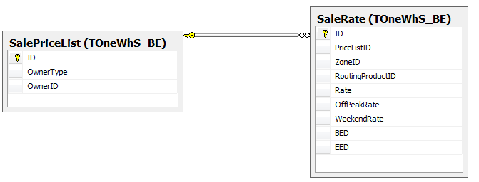

# CDR Processing

This module consists of the processes that import CDRs from the switch(es) and do needed manipulation and transformation on them. This includes pricing and summary calculation.